**WS13-Project Inspections**

**DATE: 01th december 2021**

**Project Inspections**

Team3: WorkBots Team

URL: <https://github.com/ajcalderon11/Team03WorkBotsTeam-.git>

Inspectors: Team 02 Pablo Bustillos

11 CADENA ROMAN BENJAMIN ABEL 25

12 CAISATOA RAMIREZ SEBASTIAN BERNARDO 30

13 CALDERON MERCHAN ANDY JOSUE 30

14 CORREA RUIZ KERLY YADIRA 50

15 CRUZ PANTOJA DARLING MICAELA 30

2. Requirements 10/10 complete

3. UML Diagram 7.5/10 (file uploaded in another folder), does not organize folders well

4. Classes 9/10 (plural)​​

5. Code Quality 8/10 (the .control package is missing controlle, class in plural.

6. Execution 0/10 the program does not run

_______________________

TOTAL. 34.5 /50

2. Requirements Inspection

screenshots and errors

3. UML Diagram

file uploaded in another folder

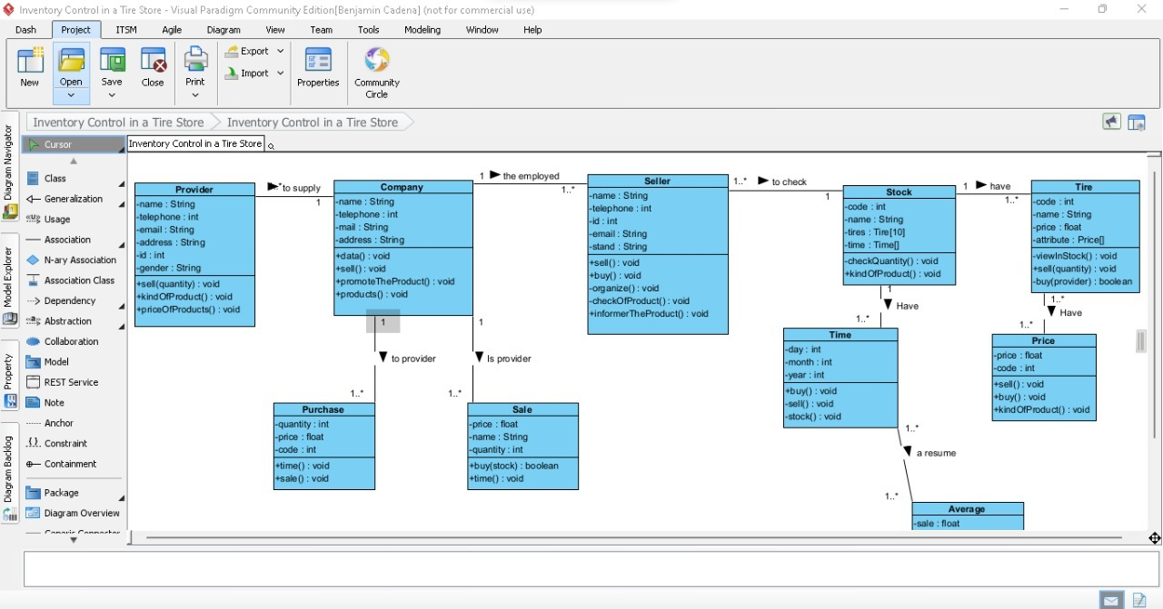

4. Classes

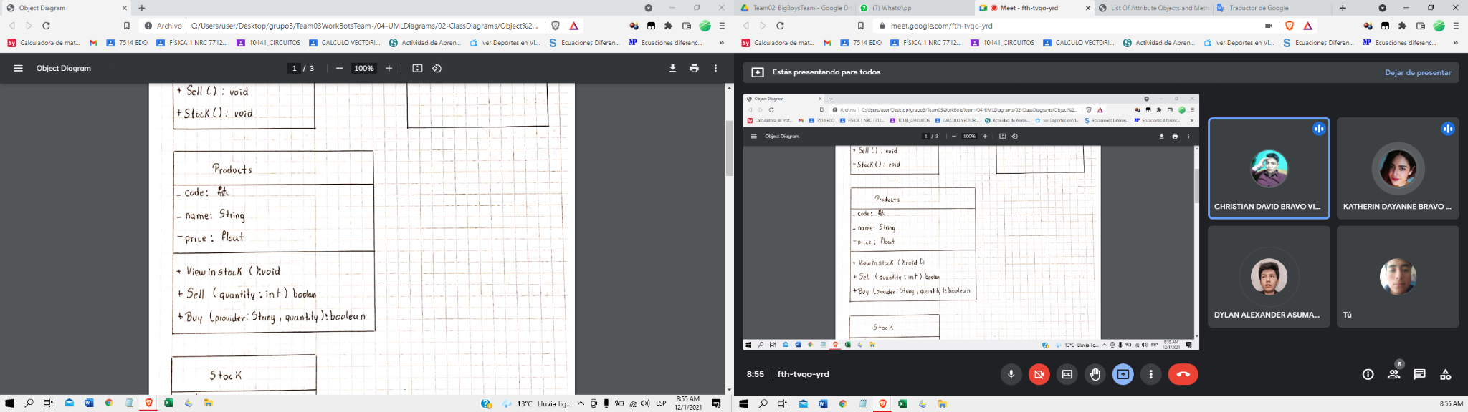

5. Code Quality

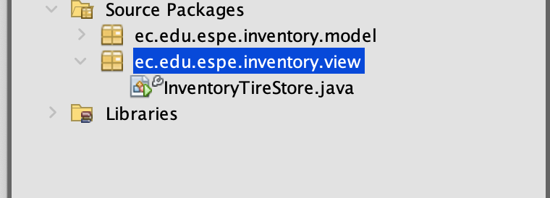

6. Execution

